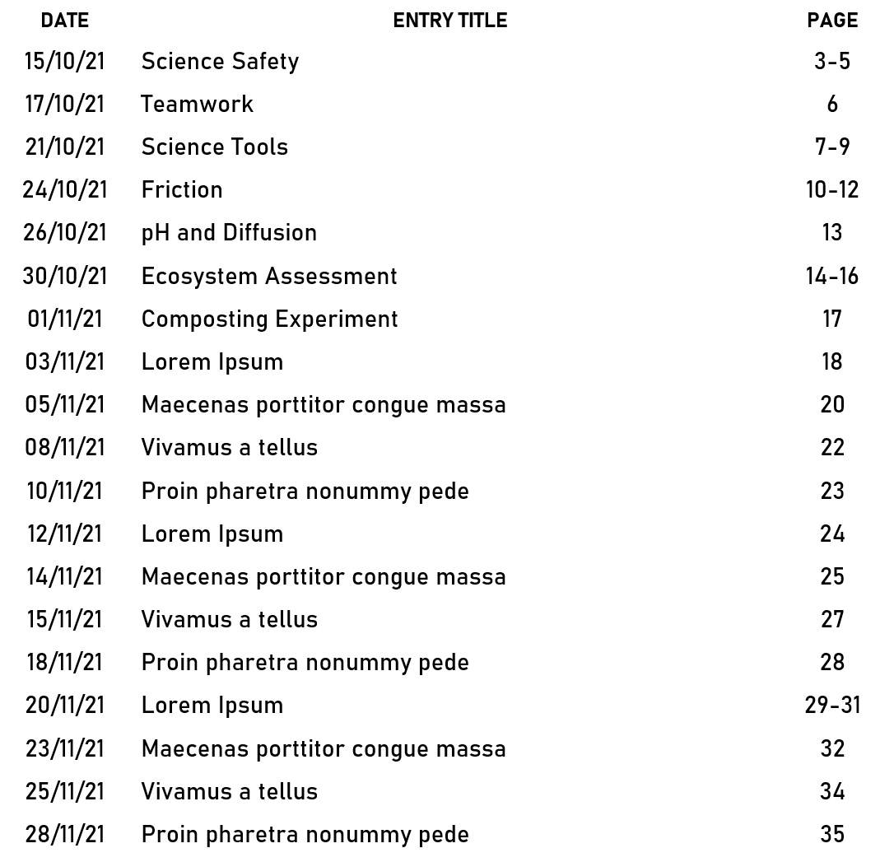

**TABLE OF ASSIGNMENTS**

ARTIFICIAL INTELIGSNCY AND MACHINE LEARING